|  |  |
| --- | --- |
| C:\Users\Rocío\AppData\Local\Microsoft\Windows\INetCacheContent.Word\Diapositiva1.jpg  **Understanding Modelling Tools for Sustainable Development** | **Module: Energy  Systems MODEL: A Reader**  Energy Systems Planning |

**Table of Contents**

**Presentation** 2

Summary 2

Learning Objectives 2

Outline 3

Questions to Activate Related Knowledge 3

**1.** **Energy Systems Modelling** 4

Energy Planning 4

Figure 1. Energy Access in Africa, Asia and Latin America 4

Figure 2. Power Outage in Firms in a Typical Month in Africa, Asia and Latin America 5

Figure 3. Life Spans and Capital Turnover of Energy Infrastructure, Plants and Equipment 7

Energy Systems 7

Figure 4. The Architecture of the Energy System 9

**2.** **Electricity Systems Modelling** 11

Figure 5. Elements of an Electricity System Model 12

**3.** **Introduction to OSeMOSYS and MoManI** 14

OSeMOSYS: The Open-Source Energy Modeling System 14

Figure 6. OSeMOSYS’ LEGO Structure 15

Figure 7: Structure of a Simple Electricity System 16

Figure 8. Generic Electricity Expansion Schedule 17

Table 1: An Example of Techno-economic Parameters of Electricity Expansion Options 18

MoManI (Model Management Interface) 18

Figure 9. Data Input with a MoManI Interface 19

Figure 10. Results Visualization with MoManI 20

**Closing Remarks** 20

**References** 21

# **Presentation**

## Summary

The synergies between energy services and development have been long recognized. Electrification, in particular, has been a keen concern in development policy-making. Building a feasible sustainable development path requires careful planning, for synergies and trade-offs within the energy sector and across other dimensions of development must be simultaneously taken into account. This module focuses on the electricity system. Ensuring a reliable electricity supply at the lowest cost possible is the main concern of electricity planning. Building related infrastructure often requires sizeable investments and careful consideration of alternative technologies. In addition,, sustainable development also requires that electricity planning meet renewable energy targets, emissions control objectives and energy security concerns, among other considerations. The module uses the Open-Source Energy Modelling System (OSeMOSYS), a full-fledged linear programming optimization model, and the Model Management Interface (MoManI), to illustrate the complexities of electricity planning in a developing country context.

## Learning Objectives

* Review the link between economic performance and energy infrastructure.
* Understand how linear optimization modelling can inform planning.
* Understand the main building blocks of energy systems modelling.
* Understand the power and weaknesses of linear optimization in energy systems modelling.
* Understand the role of energy demand and its seasonality in the modelling of the evolution of mid- to long-range energy systems planning.
* Understand how the technological and physical features of alternative energy sources interact with the demand for energy to determine the optimal energy system configuration.
* Perform an electrification analysis and identify the lowest overall cost option for a given region using the ONSSET (Open-Source Spatial Electrification Tool) standalone interface.

## Outline

1: Energy systems modelling

2: Electricity systems modelling

3: Introduction to OSeMOSYS and MoManI

## Questions to Activate Related Knowledge

* Why is energy important for economic development?
* Why are energy systems worldwide tilted towards fossil sources?
* Is it possible to have a world where all sources of energy are renewable?
* What considerations other than costs should shape the energy system of countries?

# **Energy Systems Modelling**

## Energy planning

The link between energy use, especially electricity, and socioeconomic and human development has long been recognized. No matter what a country’s development state, energy touches upon every facet of life. In high-income industrialized countries with universal and affordable energy services, energy provision raises important issues in relation to energy security and environmental compatibility, particularly with respect to emissions and their impact on climate change. In developing countries, and particularly in the least developed, energy access, affordability and reliability are prime concerns, but building energy infrastructure in a sustainable manner is also an important preoccupation in development policy (see figures 1 and 2). Energy and electricity demand is expected to multiply by three in developing countries between 2015 and 2030. Many developing countries are finding themselves in need of building energy infrastructure in line with their [nationally determined contributions](http://unfccc.int/focus/ndc_registry/items/9433.php).

### Figure 1. energy access in Africa, Asia and Latin America

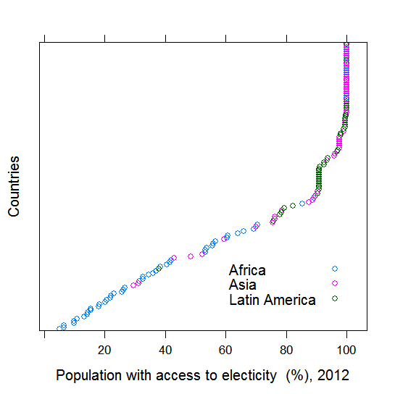

Source: Based on the World Development Indicators database, World Bank.

### Figure 2. power outage in firms in A typical month in africa, asia and latin america

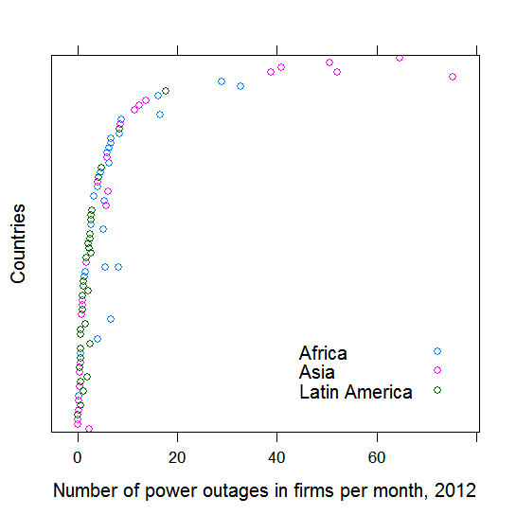

Source: Based on the World Development Indicators database, World Bank.

Energy infrastructure has an inherently long lifetime – several decades for hydro dams, power plants, coal mines, refineries, transmission systems, harbours, etc.. Information technology, entertainment and lighting equipment are all relatively short-lived, but household devices and furnaces last one to two decades, while buildings, rail networks or roads last 100 years and more (see figure 3).

Extended periods of time characterize not only energy capital stock but also the lead times of key energy system components. Constructing a large hydropower plant can take 10 years and more, coal power plants 4 to 8 years, nuclear power 4 to 10 years, and gas turbines and gas combined cycle plants between 1 and 3 years. Wind and photovoltaic plants can be erected within several months. Lead times and construction costs are highly site-dependent. In addition, there can be considerable time (up to several years) required for energy demand assessment, site selection, environmental impact analysis, stakeholder consultation, bidding processes and finance arrangements before a construction permit will be issued and construction can begin.

**Since the future is not known, planners resort to scenarios. These are not predictions, but plausible and internally consistent images on how the future may unfold.**

Energy decision makers face numerous uncertainties. An investment decision may take a decade and more until a power plant, mine or refinery will begin operating. Given the inherently slow rate of capital turnover among energy sector assets, the investment will be operating for several decades. Some of the questions driving scenario analysis include: What will fuel, e.g., diesel prices be 10 or 20 years from now? Will demand continue to grow as observed during the last decade? All are legitimate questions that need answers.

Since the future is not known, planners resort to the construction of scenarios. These are not predictions, but plausible and internally consistent images of how the future may unfold. They help understand the potential implications of investment or policy decisions, their risks and benefits. Despite uncertainties in energy demand, future fuel prices and technological developments, it is beneficial to guide decisions today based on information from longer-term scenarios.

### Figure 3. Life spans and capital turnover of energy infrastructure, plants and equipment

Source:

## Energy systems

Fast-growing energy demand in developing countries has prompted the building of a considerable amount of power plant capacity – a process expected to continue for some time. The longevity of energy infrastructure exceeds the likely time horizon for potentially disruptive environmental change and far-reaching policies for the protection of the atmosphere (Dyer and Trombetta, 2013). The risks are associated with the fact that today’s investment decisions result in a long-term “lock-in” to the technology chosen and the greenhouse gas emissions associated with this choice. The strategic nature of energy investment offers the opportunity to initiate much-needed transformation of the energy system towards long-term sustainability. Comprehensive energy system analysis and planning can assist in the choice of least-cost development pathways with full account for the risks and opportunities associated with each technology.

Comprehensive energy systems planning aims at ensuring that energy-related policy and investment decisions consider all possible energy supply and demand side options, and are consistent with broader national goals (e.g., consistent with sustainable development and the Paris Agreement on climate change). Energy planning is also a matter that extends beyond national borders, especially for countries with a high energy trade dependence or smaller countries with underdeveloped energy resource potentials (e.g., hydropower or natural gas), or where sharing infrastructure with neighbours would provide economies of scale.

**Comprehensive energy systems planning aims at ensuring that energy-related policy and investment are consistent with broader national   
development goals.**

Energy systems are inherently complex, as energy touches upon every facet of life. They comprise numerous technologies that range from resource extraction and conversion, e.g., power plants, refineries and transmission systems all the way to energy end-use and the provision of energy services (see figure 4). They involve a myriad of consumers in different economic sectors with different preferences and demands – agriculture, households, industry, commerce and transportation. In the face of this complexity, high uncertainty and multiple trade-offs, mathematical modelling has proven useful, if not indispensable. Since the early 1970s, energy models have been increasingly used to provide insights into how energy systems may evolve.

### Figure 4. The architecture of the energy system

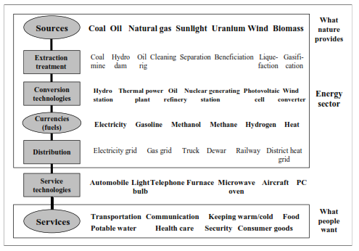

Figure 4 shows how services (what people want) are met by using a chain of interrelated technologies that are based on available resources (what nature provides). This chain of technologies converts raw natural resources into a final form that is useful/desirable to human needs. In the figure, each rectangle represents a technology category; examples are given to the right of each technology.

The results of modelling analyses guide policy and investment decisions by informing decision makers about available options, their risks and benefits, and their implications for energy security, finance, economic development and environmental impacts.

Energy systems include numerous energy chains connecting energy sources and energy services. In energy systems modelling, technologies are depicted as physical infrastructure that provides the necessary links between fuels or renewable energy flows into the energy services modern societies demand. Each technology is characterized by generation capacity, investment costs, fuel inputs (e.g., oil or sunlight), conversion efficiency, outputs (e.g., diesel, electricity), operating costs, emission of pollutants and the techno-economic parameters associated with the issue at hand. Technologies, not energy sources per se, define the long-term sustainability of the energy system. Physical energy flows from sources to services but energy systems are driven by the quantity and quality of the demand for energy services. The flow of energy is propelled by the final demand for energy services, and any effort at modelling the energy system needs to ensure that these demands, and all their variability, are met by the energy system.

Energy modelling is the art of translating the structure and flows of a national energy system as depicted into tractable mathematical formulations or mathematical equations. The equations represent rule-based interactions between the key system components, e.g., the energy production of a coal power station cannot exceed the availability of coal fuel, but must still meet the demand for energy expected from it. National economic and energy statistics provide the input to the calibration of the model (the system of equations) to correctly reflect current energy balances and energy flows (production, exports, imports, losses). In addition, information about the capacity, vintage and techno-economic performance (efficiencies, emissions, operating costs) of existing energy infrastructure (power plants, refineries, pipelines, etc.) is needed. Next the interaction of the principal drivers of energy demand (demographics, economic development, technology change, environment policy, etc.) and supply (resources, portfolio of technology options and performance characteristics) as well as policy objectives (energy security, climate mitigation, the Sustainable Development Goals or SDGs) should be determined and quantified, usually for 20 to 50 years into the future (so called scenario inputs).

**Energy is strategic: An important component of sustainable development across its key dimensions, economic, social and environmental.**

**Energy is integrated: One part of the system affects another.**

**Energy is “intra-grated:” Energy   
policies affect and are affected by a myriad of other resources.**

# **Electricity systems Modelling**

Within energy planning, electricity systems have traditionally received much attention. This is hardly surprising, for the building of a national electricity infrastructure involves decisions about the frontloading of sizeable investments in power plants and transmission systems, and these investments require in turn careful consideration of economies of scale of thermal electricity generation. Critically important, electricity planning needs to balance the demand for electricity with the limits imposed by generation potential and storage possibilities. Renewable generating technologies have added new challenges to balancing demand and supply. For the most part, renewable sources provide intermittent energy supply with variations that cannot always be accurately predicted.

The electricity system is a heavily intertwined subpart of the comprehensive energy system. The focus of this training on electricity systems modelling aims at finding the least-cost sustainable electricity system. Why do we need electricity system planning? In most developing countries/regions, existing generating capacities may or may not meet current peak demand. In any case, existing capacities will decline as ageing or defunct power plants are retired over time. Growing population and increasing income per capita (economic development) combine to increase electricity demand. Demand growth and plant retirement eliminate existing reserve capacity, further leading to a growing gap in capacity. This gap needs to be filled through investments in a new capacity to generate energy, which requires proper analysis, planning and management of scarce resource consistent with countries’ priorities.

Electricity systems are complex and require a well-organized modelling strategy. These systems are not just about power plants and input fuels or transmission lines, but involve considerations around diverse sources of energy and their various transformations to reach different consumers (see an overview in figure 5). The energy flow in an economy or society can be thought of as starting from energy sources (primary energy), which are defined as natural resources available domestically or imported. The secondary energy level (oil refineries or power plants) changes primary energy to another energy form or secondary energy, e.g., diesel and other oil products or electricity. This secondary energy is delivered to end users. In the case of electricity, this needs to be transferred through transmission and distribution lines to end users to be used in home appliances or machinery in industries. It is from these applications that useful energy services are provided in the form of heat, lighting or mechanical energy.

### Figure 5. Elements of an Electricity System Model

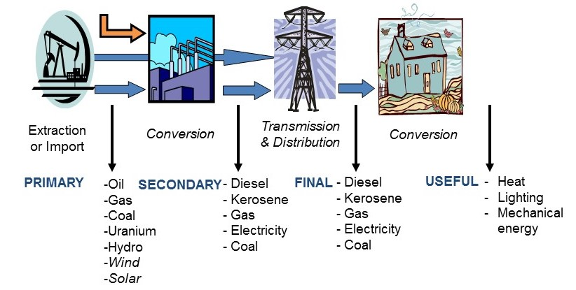

A typical electricity system model relates techno-economic aspects such as type of generating technology, enumerated in the first column of figure 5 (primary, e.g., gas combined cycle gas turbines versus wind versus coal-fired electricity generation); the extent of generating capacities, and when and how many megawatts are required (secondary column in figure 5); and operational aspects, especially demand loads. It is this chain of relations that defines the attributes of energy systems, such as generating costs, environmental and economic impacts, finance, flexibility and reliability. Electricity system analyses and planning are used for different time frames – they provide information for instantaneous load balancing, as well as for system-wide capacity expansion over time. The methodologies applied and the aims of the analyses vary accordingly. National energy system planning should take place for a 15- to 30-year horizon with a focus on expanding generating capacity and increasing the role of renewables. The 2030 Agenda suggests planning horizons of 15 years, but the nationally determined contributions include varying planning horizons. Such horizons are not necessarily relevant to national realities; countries will determine the national planning horizon most adequate to national aspirations and development goals. Reporting of progress on the SDGs can always draw from more comprehensive national planning settings.

**Energy system planning in the context of SDG 7 calls for a planning horizon of 15 to 30 years, and the focus is generating capacity expansion planning.**

Planning for the expansion of electricity capacity is generally based on some type of least-cost optimization exercise, given various constraints that mirror existing physical infrastructure conditions, access to finance, public policy regarding environmental protection or energy security considerations.

Energy modelling is data intensive. Data paucity and quality are challenges in many developing countries. A reliable and comprehensive information base is always the ideal situation to set targets and monitor outcomes, to design policies, to make evidence-based decisions, and to enable consumers to make informed choices. Unreliable and inconsistent national statistics limit cross-country analysis and undermine efforts to implement global or regional programmes. Still, a lack of data is no justification for delay in building national energy planning capability and developing energy plans. Some data, even if imperfect, are better than no data, and some initial modelling is better than no modelling at all. Missing data can be derived from first principles or estimates and still inform decision-making, provided that data are openly and transparently discussed, and modelling results can be adequately interpreted. In any event, preliminary data can always be used as placeholders until better data become available.

Modelling requires use of the best data available describing the existing electricity supply system and the drivers of energy demand as well as the best possible estimates on the evolution of the energy system, i.e., the best estimates of exogenous variables, defined as those values entered as data or parameters in the model. Numerous assumptions should be made regarding socioeconomic development, market penetration of new technologies, technology performance and geopolitics (the price of oil) to mention a few. Assumptions are not facts, hence fraught with uncertainty. Modellers, therefore, use various sets of different assumptions grouped into scenarios.

# **Introduction to OSeMOSYS and MoManI**

## OSeMOSYS: The Open-Source Energy ModelLing System

Several energy and electricity system models exist with varying degrees of sophistication, data requirements and challenges for newcomers to master the codes. They often require substantial investment in terms of human resource development (education) and model software acquisition before analysts can use the model or arrive at a stage where they can administer major changes to the model structure or add new features.

OSeMOSYS, a full-fledged system optimization model, was designed for use in developing countries to enable initial energy or electricity systems modelling with a minimum set of data and a reduced time commitment to build and operate an electricity expansion model. By not using proprietary software or commercial programming language, OSeMOSYS requires no upfront ﬁnancial commitment. The model is designed in a modular or blocks fashion. In this “LEGO-type” modular framework (see figure 6), each functional block is described in plain English, mathematical equations and programming language. These “blocks” are easy to understand, and even newcomers to modelling can start modifying an existing model and carrying out sensitivity tests after a minimum of instruction and demonstration.

**Advantages of OSeMOSYS:**

* **A minimum set of data**
* **Reduced time commitment to build and operate the model**
* **No upfront financial commitment**

The model is set to meet predefined demands for energy services, in most cases electricity. The model then considers a range of technologies that link energy sources, domestic and imported (fuel), with other technologies that provide energy services (e.g., the cooling service is provided by the technology refrigerator, the water delivery service is provided by the technology water pump, the lighting service is provided by the technology light bulb; see figure 6). The resource-to-service chains form the core of the model and they are expressed in mathematical language, i.e., in equations. Other crucial model components are constraints reflecting the physical limitations of the system, economic constraints, and public policy or environmental targets; these are also expressed in equations. As is the case for most optimization models, OSeMOSYS assumes that all inputs and outputs are fully sold and consumed at the defined prices. It also assumes perfect foresight over the planning horizon, which simply means that the decision to install or not install a power plant or a generation technology is based on knowing not only what has been installed up to that point in time, but also what will be installed at a future date.

### Figure 6. OSeMOSYS’ LEGO structure



Technologies linking the different levels of the system can be many things. The crucial point is that they have clearly defined inputs, outputs and other techno-economic characteristics. Technologies could be a coal mine, oil refinery, hydropower station, gas turbine, transmission or pipeline, water pump, vehicle, lathe or household appliances. Additional techno-economic characteristics include technology vintage, conversion efficiency, investment and operating costs, availabilities and emission profiles, among others.

### Figure 7: Structure of a simple electricity system



Note: IC = internal combustion; SC = steam cycle; CC = combined cycle gas turbine; CF = capacity factor; PP = power plant

For any application to a new electricity system, the model needs to be calibrated so it reproduces the base year flows (supply-demand balances) adequately.

Figure 7 presents a typical output of a generic electricity system analysis for the period from 2015 to 2030. Electricity demands including seasonal and daily load variations are exogenous inputs derived from the country’s demographic outlook and economic development plans. In the initial reference scenario, the generation mix is dominated by geothermal and hydropower, which supply 87 per cent of generation, with the remainder made up by diesel engines (7 per cent) and domestic natural gas (4 per cent). Wind, biomass and solar contribute a modest share of 2 per cent. The government pursues an aggressive electrification policy both via centralized generation/grid extensions and stand-alone systems, consistent with national economic development objectives. National electricity demand is now projected to increase annually by 8 per cent over the period.

Table 1 depicts the portfolio of technology (and fuel) options, including their techno-economic characteristics. Electricity imports from neighbouring countries are available at $95/MWh – electricity exchanges are capped by the 400 MW transmission capacity. Coal and oil products are imported, while domestic natural gas reserves are available but limited.

Although the share of geothermal and hydropower in total generation slips from 88 per cent to 60 per cent by 2030, these sources continue to be the country’s mainstay of electricity supply. Intermittent renewable sources add some 2,400 MW of generating capacity and generate 5,600 GWh by 2030 – almost precisely the combined amount of coal, gas and diesel with a total of 1,550 MW of installed capacity.

### Figure 8. Generic electricity expansion schedule – Generating capacities (left panel) and actual generation (right panel)



### Table 1: An Example of Techno-economic parameters of electricity expansion options

|  |  |  |  |  |  |  |
| --- | --- | --- | --- | --- | --- | --- |
|  | **Investment** | **Fixed O&M** | **Variable O&M** | **Thermal efficiency** | **Capacity factor** | **Fuel costs** |
|  | $/kW | $/kW/year | $/MWh | % | Fraction of year | $/GJ |
| Geothermal | 3,800 | 120 | 20 | n/a | 92.50% | n/a |
| Hydropower | 3,500 | 20 | 1 | n/a | 42-54% | n/a |
| Coal | 2,200 | 80 | 2 | 38% | 70% | 3 |
| Diesel engines | 750 | 40 | 4 | 23% |  | 6 |
| Natural gas | 1,100 | 25 | 13 | 50% | 85% | 5 |
| Biomass | 2,500 | 80 | 2 | 31% | 70% | 2 |
| Concentrated solar power | 3,500 | 60 | 0.9 | n/a | 45% | n/a |
| Wind | 1,400 | 55 | 0 | n/a | 30% | n/a |
| Photovoltaic | 1,200 | 15 | 0 | n/a | 20% | n/a |

## MoMANI (Model Management Interface)

Collecting necessary data to set up an OSeMOSYS model that represents the current electricity system of a country, region or city; specifying the equations and constraints; calibrating the model to the base year; and finally specifying future technology and policy options constitute challenging tasks. To assist users and reduce entry barriers to newcomers, the Model Management Infrastructure (MoManI) tool was developed. MoManI helps energy planners to construct models; manipulate data; modify, add or delete equations; operate OSeMOSYS; design and analyse scenarios; and finally visualize results.

MoManI was developed for capacity building; it offers an easy way to build a simple model, explore existing models and create different scenarios. Nonetheless, it is still an interface to the complete OSeMOSYS model. More complex and advanced models can be built from here. The easy and fast results visualization featured in MoManI allows energy planners to obtain immediate feedback on their analyses and thus ensures short turnaround times. The web-based platform allows easy sharing and dissemination of results and model contents.

As shown in figure 9, MoManI provides data input, where data for every technology, fuel and demand are specified, along with other general parameters. In this example, data are entered for the capital cost of various technologies. The data can be varied for different years, different regions and many other parameters. They can be assumed to be constant in the modelling period, as with the transmission and distribution numbers in figure 9.

### Figure 9. Data input with A momani interfacE

### *Note: These numbers are for a fictional country*

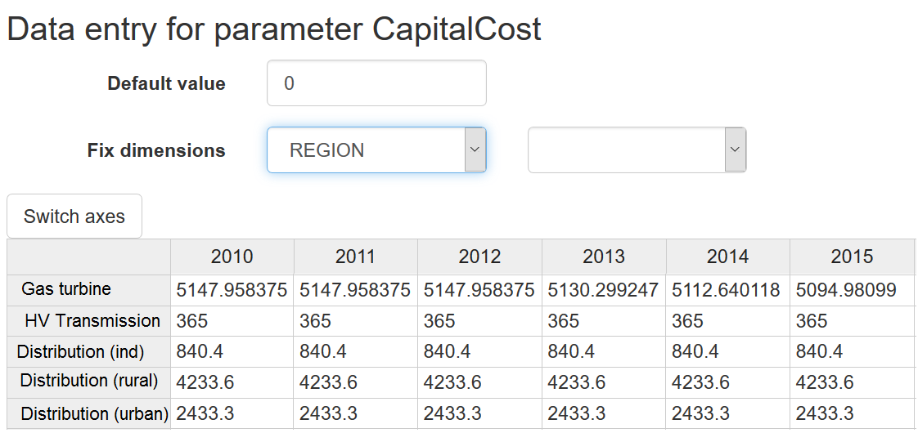

Once all required information has been entered, the model is ready to run. This can take anywhere from one minutes to several days, depending on the complexity of the model and the processing power available. MoManI can automatically visualize the results. In figure 10, results are shown for electrical generation (actual output from the power plants each year) until 2040. This shows the optimum results that will meet demand in the cheapest way, but is not a prediction of the future system. Planners and modellers can use these results further to assess when to invest in certain technologies, and decide if they are happy with this mix (if not, they should implement policies to restrict/encourage other technologies). Further results can show the amount to be invested, the amount of emissions and many other factors.

Through this interface, it becomes easy to compare the results of different scenarios and assumptions. For example, one could analyse the difference in emissions caused by a policy to restrict coal power plants, or to see the additional cost required to meet a certain target on renewables.

### Figure 10. Results visualisation with momani

### *Note: These results are for a fictional country*

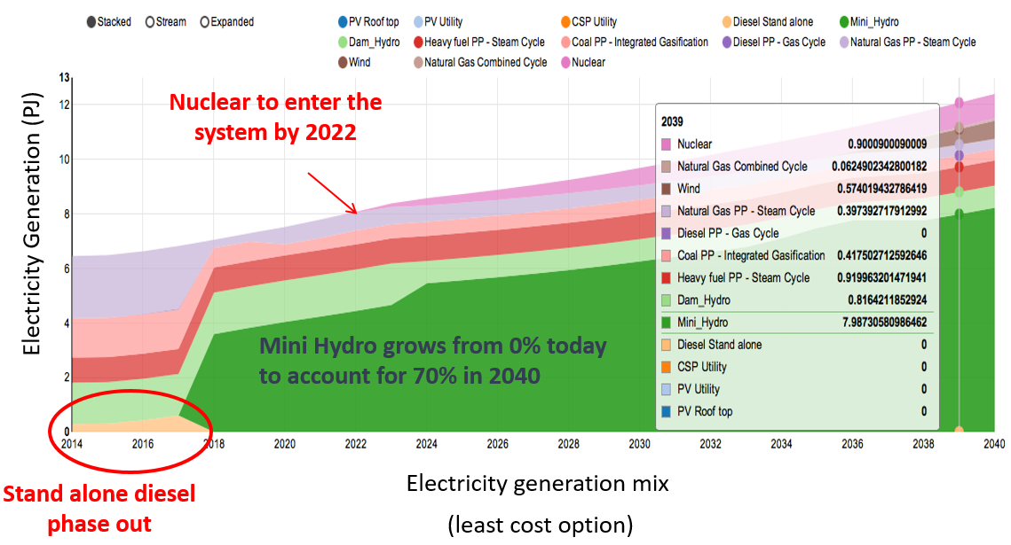

# **Closing remarks**

Energy systems, and specifically electricity systems, are crucial to providing services to people around the world and a vital part of sustainable development. The expansion of energy systems has the potential to improve quality of life and economic growth, but they can also have disastrous environmental effects if emissions increase. If poorly planned, energy systems can lead to energy shortages that impede economic growth, low electricity access levels and blackouts. If emissions increase, they can exacerbate climate change and other environmental problems.

To improve the ability to plan these complex systems, modelling is needed. This allows planners to gain an understanding of the best strategies under certain assumptions and scenarios, and to create robust plans. Models can provide insights that give planners the ability to uncover potential impacts of different actions.

OSeMOSYS is a useful model for energy planning. This open-source energy modelling system allows for the creation of relatively simple models, but also more advanced models that incorporate all the complexity of a real energy system. Its open-source nature means that there is no financial cost. Modellers in any country can use it at their discretion, and will be able to modify it and add components that might be necessary for a specific country or scenario.

Modelling has one major drawback: It is only as good as the data feeding the model and the technical capacity of modellers. Thus, if data quality is poor, or scenarios are badly defined, results need to be treated with caution and the understanding that there are inaccuracies. Nevertheless, different data can be explored to understand what the impacts are, so that modellers and planners can get an understanding of the sensitivity of the model.

OSeMOSYS is an energy system model that focuses on the planning and design of energy systems, but it doesn’t have a geospatial component. This is an issue covered in another module in this course.

# **References**

Dyer, H., and M. J. Trombetta (2013). *International Handbook of Energy Security.* Cheltenham, United Kingdom: Edward Elgar.

References missing for the figures, also some standard references on Osemosys publications, CLEWs work (?) and things like that